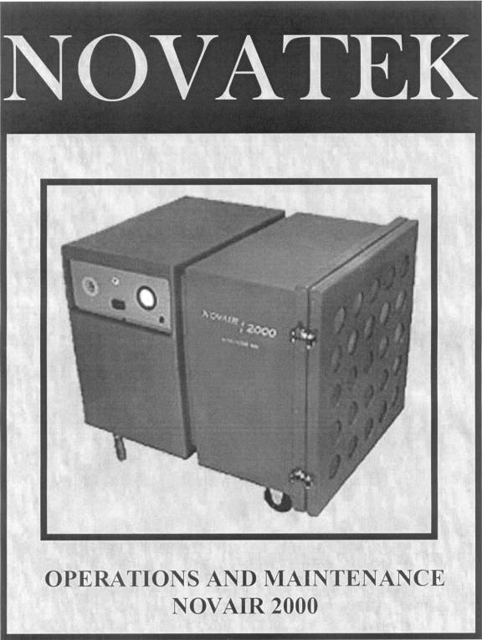

© Copyright 1997 by NOVATEK Corporation
Revision 2002

All rights reserved printed in the United States of America. No part of this manual may be used or reproduced in any form or by any means, stored in data base or retrieval system, without prior written permission from NOVATEK Corporation.

Making copies of this manual for any purpose other than your own personal use is a violation of the United States copyright laws.

December 1,2002 issue 1.0

Specifications subject to changes without notice!

TABLE OF CONTENTS

SECTION I

Introduction........................................................................................................................4

SECTION II

General Description.........................................................................................................4

SECTION III

Routine Maintenance......................................................................................................5
Control Description.......................................................................................................5,6

SECTION IV

Prior to Start-Up...............................................................................................................6
Start-Up...............................................................................................................................7

SECTION V

Replacement & Disposal of Filters...........................................................................7,8

SECTION VI

Completion of Project .....................................................................................................8
Parts Breakdown............................................................................................................…9
Diagram of Unit and Control Panel..............................................................…9

SECTION VII

Safety Rules.......................................................................................................................10
Trouble Shouting..............................................................................................................10

SECTION VIII

Wiring Diagram................................................................................................................11
SECTION I

INTRODUCTION

This operation and maintenance manual is furnished with each NOVAIR 2000 unit. It outlines general equipment use and the operation and maintenance requirements for efficient and safe operation.

READ ALL INSTRUCTIONS AND DATA IN THIS OPERATION AND MAINTENANCE MANUAL PRIOR TO OPERATION OF THIS EQUIPMENT.

These instructions are for your protection and convenience. Please read them carefully since failure to follow the precautions could result in injury. When ever using electric powered equipment, basic safety precautions should be followed.

If after reading this manual or if anything seems unclear, contact a NOVATEK authorized distributor or NOVATEK directly by dialing 1-866-563-7800.

SECTION II

GENERAL DESCRIPTION

The NOVAIR 2000 , a portable Electric 2000 CFM Air Filtration Unit designed and manufactured by Novatek Corp. This unit removes any hazardous or non-hazardous air borne particulate from an enclosed room.

This unit has a three stage filtering system. The first stage is a Pre-Filter containing most of the dust and dirt and is easily replaced. The second stage is a Ring Filter containing any dust and dirt able to work its way past the Pre-Filter. The final stage is a 99.97% 0.3 micron Hepa Filter that contains any dirt or dust that makes it through the other two filters.

The NOVAIR 2000 requires a 110/115V - 20 Amp, single phase power source.

WARNING

Do not use circuits exceeding specified voltage. Higher voltage will damage controls and could cause shock or fire hazard.

SECTION III

ROUTINE MAINTENANCE

Inspect the unit for any loose or damaged parts every time prior to use. CAUTION: Make sure power supply is off prior to inspection!

1. Wipe outside surfaces of unit to remove accumulated dust or dirt. Clean out dust and dirt from control panel.

2. Periodic checks should be made to filter brackets to ensure thumbscrews and knobs are securely tight.

3. Filters should periodically be checked and replaced if needed. This will help ensure proper air flow and extend motor life.

4. Inspect power connection to Negative Air Machine. Make sure recessed plug is secure to the panel. If recessed plug is loose electrical shock or shortage may occur.

Caution: DO NOT TAMPER WITH THE BLOWER HOUSING OR WIRING OF THE CONTROL PANEL OR MOTOR. TAMPERING COULD RESULT IN FAULTY UNIT OPERATION AND VOID THE FACTORY WARRANTY

CONTROL DESCRIPTIONS

1. Power Switch

This low/off/high power switch provides power to the blower motor when set to the low or high positions.

2. 20Amp Breaker

This is attached to the units main power supply to help protect the blower motor against power surges. This is also included to help protect the operator against electrical shock.

3. Differential Pressure Gage
This gage is used to determine air flow through the three stages of filters. The filters will begin to load with dust and dirt. The gage will begin increasing from 1.5” to about 3.0” when filters are completely full.

4. Barbed Fitting

This is used with the minhelic gage to help regulate the differential pressure as the filters begin to load.

5. Male Recessed Plug

This is where the main power supply is attached to the unit. The unit draws about 15amps, so make sure you have an industrial extension cord supplying power.

RECESSED BREAKER PRESSURE
PLUG GAGE

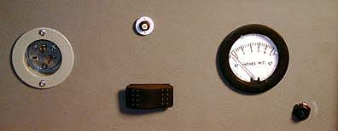

SWITCH FITTING

SECTION IV

PRIOR TO START-UP

A. Make sure to remove any excess dust/dirt from exterior housing and control panel.
B. Make sure Hepa Filter and Pre-Filters are installed properly with a positive seal.
C. Check that unit is connected to an open 20Amp 110/115 volt breaker.
D. Check exhaust port connections for tight seal.
E. Make sure unit is positioned in open area away from any entrances into the contained work area.

START – UP

A. The NOVAIR 2000 should be positioned at a minimum distance away from workers access openings or towards the center of the room in the containment.
- Connect 12” exhaust port to hose and exhaust to non-contaminated area.

Check Hepa Filter is properly installed in unit and sealed to flange by utilizing
mounting brackets.
- Install Ring filter and Pre-Filter pads into unit.
- Lock brakes on caster wheels prior to starting unit
- Attach power cord to male recessed plug on control panel.
- Turn unit on and check pressure gage, which should read about 1.5”wg. This is the reading when unit has all new filters. Reading will increase as filters become loaded with contaminants. The reading will be about 3.0”wg. when filters are full.
CAUTION: At this point in the start-up procedure unit is drawing power.
- By pushing the switch to the left the unit will operate in low speed (1200cfm) or push the switch to the right to operate in high speed (2000cfm).

SECTION V

Replacement of Filters

A. The condition of the working area will determine the frequency of filter change outs. When the filters begin to load the pressure gage will start to climb. Once the gage reaches 2.5”-3.0” the filters will need to be replaced.

Pre-Filter

- With unit in operation, remove and dispose of Pre-Filter. Replace with new pre-filter and check pressure gage. If pressure gage still exceeds 2.5” Ring Filter should also be replaced.

Ring Filter

A. With unit in operation, remove and dispose of ring filter. Replace with new ring filter and check gage. If pressure gage still exceeds 2.5” Hepa Filter should be replaced.

Hepa Filter

- Turn unit off and be sure to disconnect power supply.
- Remove Pre-Filter and Ring Filter.
- Remove Hepa Filter by loosening thumbscrews on filter brackets. Remove filter brackets and slide out Hepa Filter and dispose of filter. 1.) Inspect the gasket on the new Hepa Filter for any cracks, gaps or defects. Any defective gaskets must be replaced. 2.) The gasket end of the Hepa Filter is placed in unit first and pressed firmly against flange to form a tight seal. 3.) Re-install filter brackets with all hardware originally supplied. Make sure once brackets are installed the four thumbscrews are tightened to seal filter to flange. NOTE: When Hepa Filter is changed the Pre-Filter and Ring Filter should also be replaced with new.

Disposal of Filters

A. When any of the filters in this unit need replacing, they are now considered hazardous waste and should be disposed of properly. NOTE: When changing filters or working with this unit always wear protective equipment.

SECTION VI

Project Completion

At the completion of the project the filters should not be removed. The NOVAIR 2000 should be sealed on both intake and exhaust ends. Seal with poly plastic and tape. Doing this will help prevent re-contamination of the area after final cleanup.

PARTS BREAKDOWN

Ref. Part No. Description

1 F2030 MALE RECESSED PLUG
2 F2055 20 AMP BREAKER
3 F2050 POWER SWITCH
4 F3000 PRESSURE GAGE
5 F3001 BARBED PRESSURE FITTING
6 F2010 BLOWER HOUSING & WHEEL
7 F2020 BLOWER MOTOR
8 F2025 CAPACITOR
9 F3002 DOOR LATCHES
10 F3005 FILTER BRACKETS
11 H1005 KNOBS
12 H1235 THUMBSCREWS
13 F3004 WHEELS-RIGID
14 F3003 WHEELS-SWIVEL
15 F3010 HINGE (Not Shown)

DIAGRAM OF UNIT AND CONTROL PANEL

SECTION VII
SAFETY RULES

The Novatek Corporation Negative Air Machine (NOVAIR 2000) is a highly efficient system designed to help eliminate any air borne particulates. In order to properly operate this unit effectively and safely, the following safety precautions should be strictly adhered to:
1. Do not leave unit unattended when connected to power source. Turn OFF electric supply and disconnect from power source, every time the unit is not being used and/or before servicing.
2. Do not operate with damaged and/or malfunctioning parts. If unit is not working as specified in this manual due to misuse repair damaged parts or return to an Authorized Repair and Service Center.
*Always repair with genuine NOVATEK parts, to ensure operational safety and to protect units limited warranty.
3. Keep loose clothing and all body parts away from blower when in operation.
4. Sweep tile surface and remove any excess buildup of wax residue prior to heating surface. This will help to eliminate any fumes and fowl odors.
5. Turn off power before Hepa removal.
6. Do not operate around flammable or combustible liquids and/or gases.
7. Electric shock may occur if operated in wet conditions.
8. Never operate the unit in a manner where there is the possibility of physical contact with the blower wheel while in operation.
9. It shall be the responsibility of the unit owner to insure that the equipment is maintained in a safe operating condition.

TROUBLE SHOOTING

This unit has several features for your safety and convenience. Here are some trouble shooting and maintenance tips.

1. The NOVAIR 2000 comes equipped with a 20A breaker, which is used to protect the blower motor and operator against any sudden electrical surges.
A. If the unit is plugged in and turned on but blower will not operate.
Check breaker on front control panel of unit to make sure it does not need to be pushed in to reset breaker.
B. If unit still will not operate.
Check the circuit breakers in the electrical supply panel to make sure the breaker is not tripped.
C. If unit at this point still will not operate.
Remove front control panel to verify that all wires are connected. If any lines are off reconnect.
NOTE: IF AFTER FOLLOWING THESE TWO PROCEDURES POWER IS NOT RESTORED CONTACT A NOVATEK FACTORY TECHNICIAN.

SECTION VIII

WIRING DIAGRAM

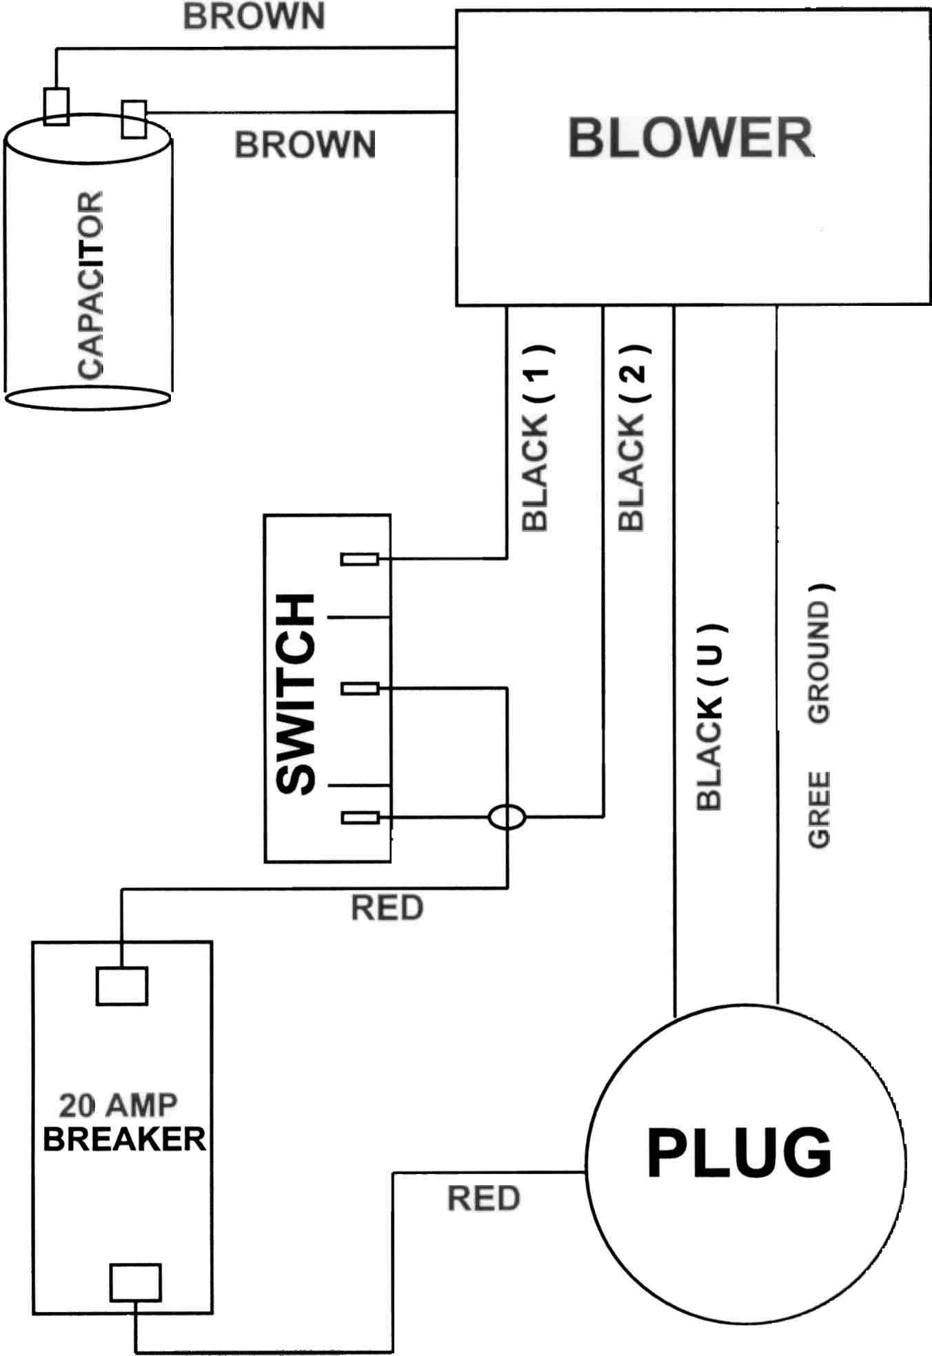

NOVATEK CORPORATION LIMITED WARRANTY

The UNITS manufactured by NOVATEK CORPORATION are warranted to be free from defects in material and workmanship for a period of 90 DAYS from date of purchase from NOVATEK CORP. This warranty does not apply to accessories.

This warranty applies only to UNITS purchased new from NOVATEK CORPORATION. This warranty does not apply to any UNIT which has been abused, misused, modified or repaired by someone other than NOVATEK CORPORATION or its authorized repair center.

If a UNIT proves defective in material or workmanship within one year of purchase from NOVATEK CORPORATION, it should be returned to NOVATEK CORPORATION, transportation pre-paid. The return must be authorized by a RETURN AUTHORIZATION NUMBER (R.G.A. #) obtained from NOVATEK CORPORATION prior to returning the UNIT. All packages must show clearly on the outside the return authorization number. All packages received without any R.G.A. # on the outside will be refused by NOVATEK CORPORATION receiving department.

Warranty claims will only be considered upon adequate proof of date of purchase. NOVATEK CORPORATION will, at its option, REPAIR or REPLACE DEFECTIVE PARTS. Repairs or replacements are warranted as above for the remainder of the original warranty period. The sole liability of NOVATEK CORPORATION and the user’s exclusive remedy under this warranty is limited to the repair or replacement of the defective product.

THERE ARE NO OTHER WARRANTIES EXPRESSED OR IMPLIED AND NOVATEK CORPORATION SHALL NOT BE LIABLE FOR INCIDENTAL, CONSEQUENTIAL OR SPECIAL DAMAGES, OR ANY OTHER EXPENSES OR REPAIR OR REPLACEMENT AS DESCRIBED ABOVE.

All warranty claims should be forwarded to :

NOVATEK CORPORATION
155 Philips Road
EXTON, PA 19341

ATTENTION: CLAIM AND SERVICE DEPARTMENT
R.G.A. # ____________

CALL Toll Free at 1-866-563-7800 for your RGA number prior to shipping machine back.

Also include a brief description of the problem as well as a phone number, contact name and return address in case NOVATEK CORPORATION service personnel has to get in contact with you.

